The files that I am providing are the first version of the app, the second version of the app, and the final version of the app. I used Adobe XD to build all the versions of my app. Adobe XD is a program that allows you to design and build prototypes of apps. All the programs and versions of the app can be launched by Adobe XD or the website that is provided (<https://xd.adob.com/view/2e9019fb-8eb1-4c79-9f40-3851bef351a7-7bc3/>). 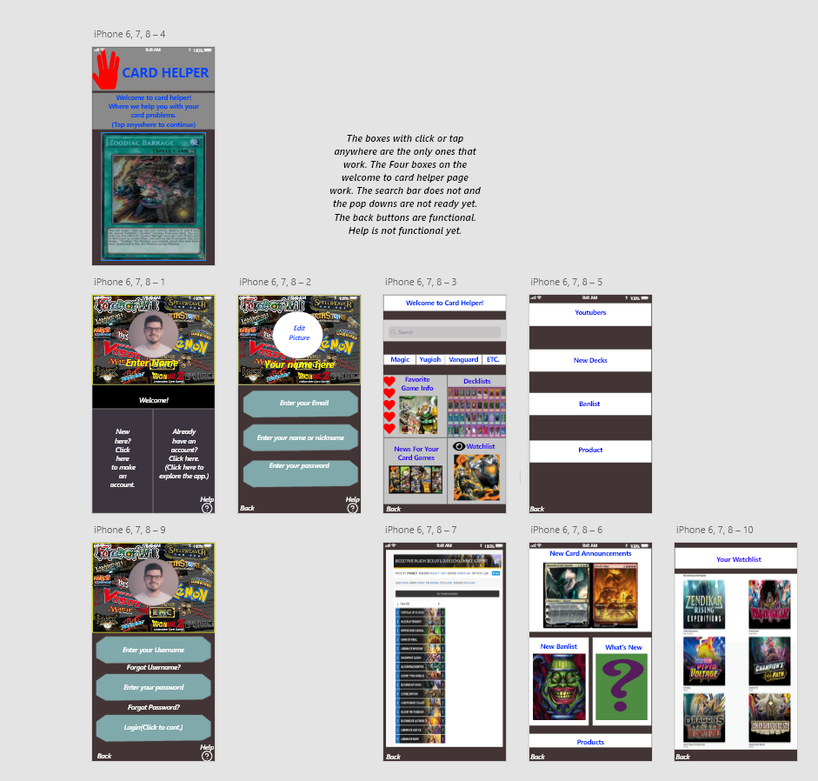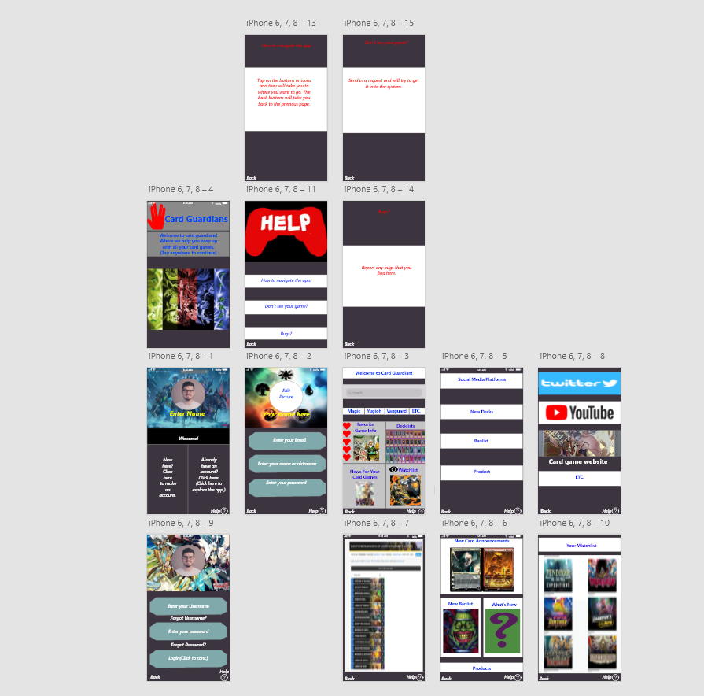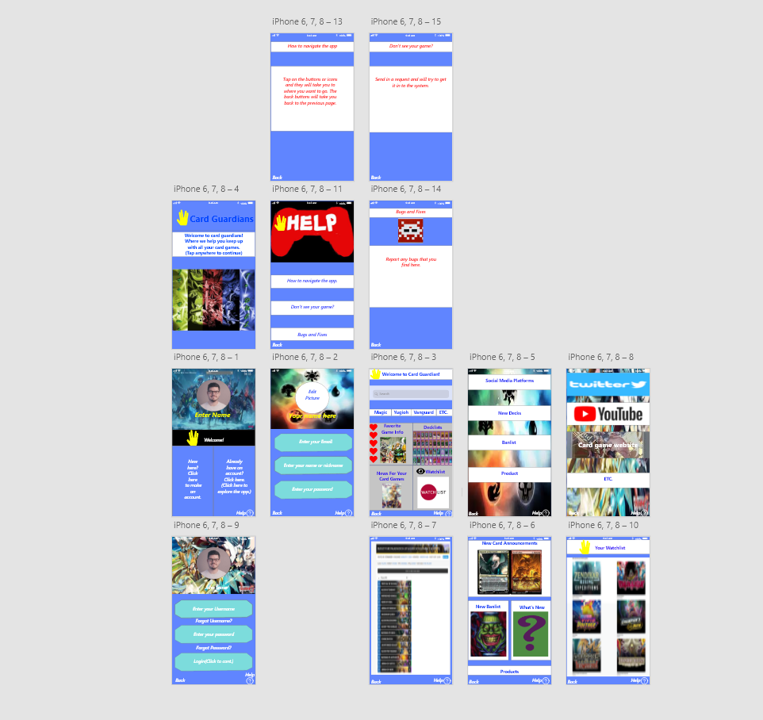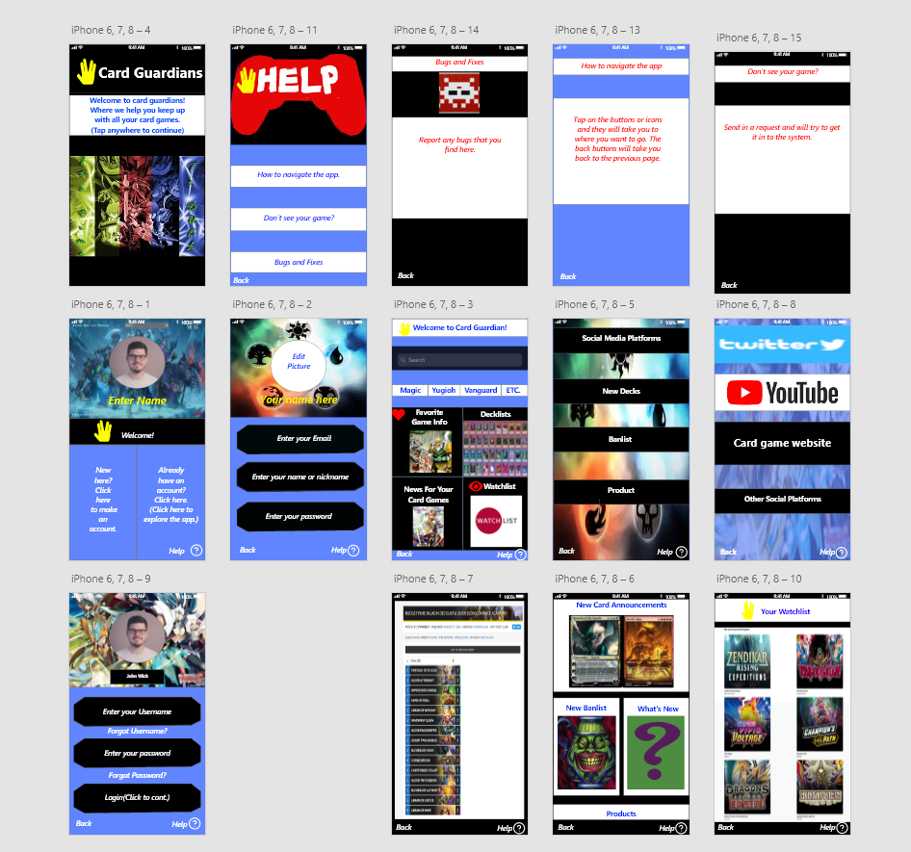

This is the first version of the project with minimum user interactions. The help button was not programmed in yet and most of the layouts were not finalized yet. Some of the buttons did not have anywhere to go and were not programmed yet. The back buttons worked and you could navigate to each page, but the app still needed improvement.

In this version of the app, the layouts and color scheme were changed and more of the buttons got programmed in. Most notable, the help buttons finally got their own page with different questions and answers. The art board five got one of the buttons programmed in so I could have some more user interaction with the design.

In this version, I made sure that all the back buttons went to the right place and the help buttons were programmed to go to the right help tab. I also changed the color scheme and made some improvements to the pictures.

In the final design, all that was improved on were the layout and the color scheme. After looking at user reviews, I realized that the most common or detailed comment was that the layout or color scheme did not look good on the eyes. So I went back and changed the color scheme to make sure that the user could see the words, and I fixed the parts that were too bright for the user.